

**DonMentia trip to Cleethorpes**

**DonMentia** is offering a **free** trip to **Cleethorpes**

for people with dementia and their regular carer on

**Friday 19th July 2024** to include lunch

*Please meet at* ***10.15*** *at* ***Doncaster station booking office***

*(train leaves at 10.37am)*

**Places are limited so it’s a case of first come first served**

*However, if you sign up and then find that you are unable to attend,*

*please phone Eileen as soon as possible on 01302 723322*

*or email* [*eileen@donmentia.org*](mailto:eileen@donmentia.org) *to allow someone else to be offered the place*

Whilst this event is **free** to all participants**,** if you drop out after

**Friday 5th July 2024**, a fee of **£25 per person** will be payable due

to expenses that will already have been incurred

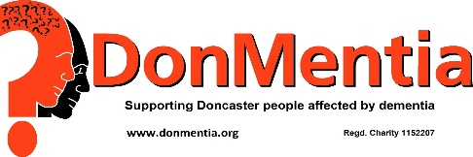

If you wish to be included, please complete the details below:

*Keep this part but return the lower part (only) to Eileen or other DonMentia volunteer*

*Or post to Stone House, York Road, Old Scawthorpe, Doncaster, DN5 7UN*

***You will only receive a reply to this form if there is problem***

***No dogs except guide dogs***

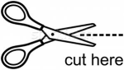***.......................................................................................................***

**Cleethorpes 2024**

**I/we...............................................................................................................**

tick

one

box

wish to go on the outing to Cleethorpes on **Friday 19th July 2024**

wish to go, but will do so independently and join you for **lunch only**

**Please wear your DonMentia badge**

Tick box if you do not have a badge Person 1 Person 2

Please underline here if you are taking a **fixed** **wheelchair,**

a **folding wheelchair** or **walking frame**

*I accept this trip is undertaken at my/our own risk and*

*DonMentia has no responsibility for any mishaps*

Signed (carer only)..............................................................................................

***Now complete other side***